15/02/2022

First look at the data

Run210818_raw data.csv
[869714 rows x 45 columns]

Run210929_raw data.csv
[413335 rows x 49 columns]

Run211011_raw data.csv
[311688 rows x 49 columns]

Run211110_raw data.csv
[294947 rows x 49 columns]

Run211125_raw data.csv
[447329 rows x 49 columns]

Run211207_raw data.csv
[528566 rows x 49 columns]

Run220112-220118_combined_raw data.csv
[172965 rows x 49 columns]

Run220114_raw data.csv
[322626 rows x 49 columns]

After talking with Houssein, I understand that one experiment can concern 50 to 60 samples, whereas each run can only take 48 samples. This means that experiments can span over more than one run.

However, I see a discrepancy in the number of rows (the number of barcodes sequenced) from one run to the other, which, to me, seems like we are going to have to “drop” some barcodes to be consistent within each experiment. Unless I missed a point?

I first renamed the files so that they match yy/mm/dd format instead of dd/mm/yy for easier handling.
Then I started running some checks on the data, to see if the counts match, and later on to check for duplicates to ensure data unicity; etc.

- Rename the files so that they match yy/mm/dd format instead of dd/mm/yy
- Check the reads number between each run and for each experiment

16/02/2022
From publication https://www.nature.com/articles/s41467-019-08595-2

Cellular barcoding computational analysis
Raw sequencing data was preprocessed using the R package edgeR⁵⁰ as previously⁵¹. In brief, reads were split according to sample index, and barcodes associated with each sample were recorded in a barcode-count matrix. To ensure high quality of the data, samples with <8000 reads, as well as samples with less than two technical replicates having over 8000 reads were removed from downstream analysis.
To filter out non-specific PCR amplification, barcodes detected in less than two technical replicates per samples were discarded.
Technical replicates were pooled (except for Supplementary Figure 1H) by adding the reads in each replicate and barcode, and normalized to one (i.e. such that the sum over all barcodes per sample equaled one).
If technical replicates from the same sample were processed in different sequencing runs, they were first normalized, then pooled, and normalized again, to mitigate the effects of differing sequencing library sizes.
Filtered and normalized data was analyzed and visualized using the statistical computing language R, specifically the package ggplot2⁵². For determining significance in the differences of means between two conditions, the Welch Two Sample t-test was performed on log-transformed values, and p-values <0.05 were considered statistically significant.
Luca :
Hi Nina,
We don't have technical replicates, only biological: with 80 drugs, four replicates per compounds (not considering that each experiment had a control, and some compounds were tested more than once) it would have been too much, and I'm not sure it would have been really useful. Compared to western blot, I guess the main difference between runs (but also between samples within the same run) is the sequencing depth. In another study, where we were interested in calculating the fold increase/decrease versus the control, we normalized the data to the sample with the highest number of reads (I guess it's like doing it by considering that the total number of reads is 1, but we didn't want to deal with numbers below 1...). One specificity of our data is that we only have around 25 000 barcodes. If we look at all the controls (and time zero) from the different experiments, we should be able to have a list of the real barcodes, and consider junk/errors the others. The only caveat I see is the (remote) possibility of having a subpopulation that is substantially underrepresented in the control and thus below the detection threshold (because it grew slowly during the amplification after the selection of the 25 000 cells), but particularly insensitive to a certain compound, and therefore detectable in treated cells. I guess it's not very likely, and we should be able to see it.
The whole idea of the project is that some subpopulations display an intrinsically defined sensitivity to different compounds. I think our data are consistent with this, but I'm sure some other subpopulations can be enriched during the treatment in a random way. Thus, it would be difficult to discriminate between such subpopulations and false barcodes (such as errors during PCR). Maybe we can solve the issue by using the controls to define a list of real barcodes. By the way, I was thinking that in the future manuscript, once we discuss this point (intrinsically more/less sensitive versus random), we could decide to consider only the subpopulations/barcodes that behave in a consistent manner between replicates (at least with certain drugs), to decrease the noise and improve clustering.

controls in each run (‘Contro’) :

- Run210818_raw data.csv
Contro1_000u_exp010821_run180821_03
Contro2_000u_exp010821_run180821_04
Contro3_000u_exp010821_run180821_05
Contro4_000u_exp010821_run180821_06
Contro1_000u_exp040821_run180821_25
Contro2_000u_exp040821_run180821_26
Contro3_000u_exp040821_run180821_27
Contro4_000u_exp040821_run180821_28

- Run210929_raw data.csv
Contro1_000u_exp300821_run290921_01
Contro2_000u_exp300821_run290921_02
Contro3_000u_exp300821_run290921_03
Contro4_000u_exp300821_run290921_04
Contro1_000u_exp130921_run290921_32
Contro2_000u_exp130921_run290921_33
Contro3_000u_exp130921_run290921_34
Contro4_000u_exp130921_run290921_35

- Run211011_raw data.csv
Contro1_000u_exp200921_run111021_09
Contro2_000u_exp200921_run111021_10
Contro3_000u_exp200921_run111021_11
Contro4_000u_exp200921_run111021_12

- Run211110_raw data.csv
Contro1_000u_exp130921_run101121_20
Contro2_000u_exp130921_run101121_21
Contro3_000u_exp130921_run101121_22
Contro4_000u_exp130921_run101121_23
Contro5_000u_exp130921_run101121_24
Contro6_000u_exp130921_run101121_25
Contro7_000u_exp130921_run101121_26
Contro8_000u_exp130921_run101121_27
Contro1_000u_exp181021_run101121_38
Contro2_000u_exp181021_run101121_39
Contro3_000u_exp181021_run101121_40
Contro4_000u_exp181021_run101121_41

- Run211125_raw data.csv

- Run211207_raw data.csv
Contro1_000u_exp151121_run071221_01
Contro2_000u_exp151121_run071221_02
Contro3_000u_exp151121_run071221_03
Contro4_000u_exp151121_run071221_04

- Run220112-220118_combined_raw data.csv
Contro1_000u_exp271221_run180122_17
Contro2_000u_exp271221_run180122_18
Contro3_000u_exp271221_run180122_19
Contro4_000u_exp271221_run180122_20

- Run220114_raw data.csv

18/02/2022

I used the experiment D) 210913 as an example.

The corresponding data for this experiment lies in 2 different runs : run_210929 (run_id 2 : 413334 seq.barcodes) and run_211011 (run_id 3 : 311687 seq.barcodes).

The controls for this experiment are located in the run_id 2 run_210929.
- Contro1_000u_exp130921_run290921_32
- Contro2_000u_exp130921_run290921_33
- Contro3_000u_exp130921_run290921_34
- Contro4_000u_exp130921_run290921_35

First, I checked that all 413334 seq.barcodes from run_210929 are unique and yes they were.

I summed the reads for each sequenced barcode among the 4 controls and created a new column in the data frame called ‘sum_controls’ and containing the corresponding sums.

Q. How many barcodes remain in the data frame if we :
- drop barcodes that have 0 reads in the summed controls: 41117
- drop barcodes that have <5 reads in the summed controls: 9220
- drop barcodes that have <10 reads in the summed controls: 7648
- drop barcodes that have <50 reads in the summed controls: 3312
- drop barcodes that have <100 reads in the summed controls: 1695

Considering that there should be 25’000 barcodes present in the cell population, I’d say we go for a filtering that will only remove the barcodes that are not present in the summed controls (0 reads).

21/02/2022

From there, comes the question of inter-run compatibility of this filtering.

Q. How many seq.barcodes from control_filtered run_210929 (41117) are also present in run_211011 (311687 seq.barcodes)?
A. 22078 seq.barcodes.

Does this mean that if we want to be able to integrate both runs together (run_210929 and run_211011) in order to analyze/cluster the compounds from experiment D) 210913, we need to drop 19’039 barcodes from the run_210929 (41’117 - 22’078 )?

$ python analyze_runs.py

Exp in each run

Run210818_raw data.csv
['exp010821', 'exp040821']

Run210929_raw data.csv
['exp300821', 'exp130921']

Run211011_raw data.csv
['exp130921', 'exp200921']

Run211110_raw data.csv
['exp200921', 'exp130921', 'exp181021']

Run211125_raw data.csv
['exp181021']

Run211207_raw data.csv
['exp151121']

Run220112-220118_combined_raw data.csv
['exp151121', 'exp271221']

Run220114_raw data.csv
['exp271221']

→ UPDATE OF THE TABLES
Wrote Luca and Houssein to have their opinion on how to normalize or drop absent barcodes from one experiment to the other.
I would also have a look on how to deal with missing data for cluster analysis. If you happen to have some knowledge about it, please share :)

22/02/2022
5 Ways to Deal with Missing Data in Cluster Analysis
Optimal clustering with missing values

I can start analyzing the experiments that are contained within a single run, using a first step consisting in dropping all barcodes that were not found in the controls (i.e. barcodes with 0 reads in the summed 4 controls). The concerned experiments are :

Experiments Exp_date Run_date containing the corresponding controls
A 210801 210818
B 210804 210818
C 210830 210929
F 210913_bis 211110

23/02/2022

experiment A
The data is contained in the file Run210818_raw data.csv
This file contains initially 869’713 barcodes.
Controls are named :
Contro1_000u_exp010821_run180821_03
Contro2_000u_exp010821_run180821_04
Contro3_000u_exp010821_run180821_05
Contro4_000u_exp010821_run180821_06
We make a new column summing the 4 controls and use it to filter in order to drop every barcode that has 0 reads among the summed_controls.
The remaining data frame contains 89’340 barcodes that will be used to do the clustering.
The filtering reduced the number of barcodes by approximately 90%.
I’ll save the dataframe as a new csv file for further processing and analysis : Run210818_filtered_exp010821.csv
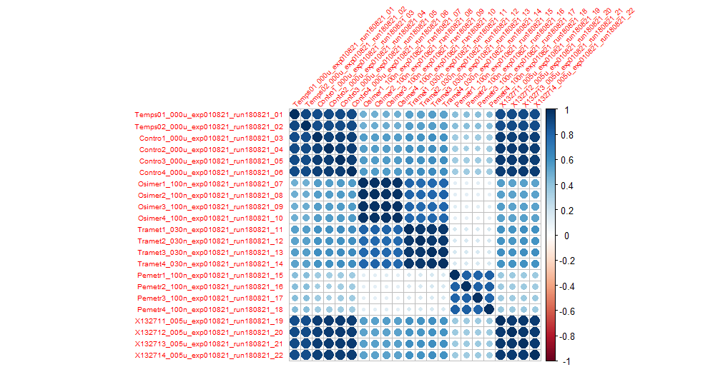
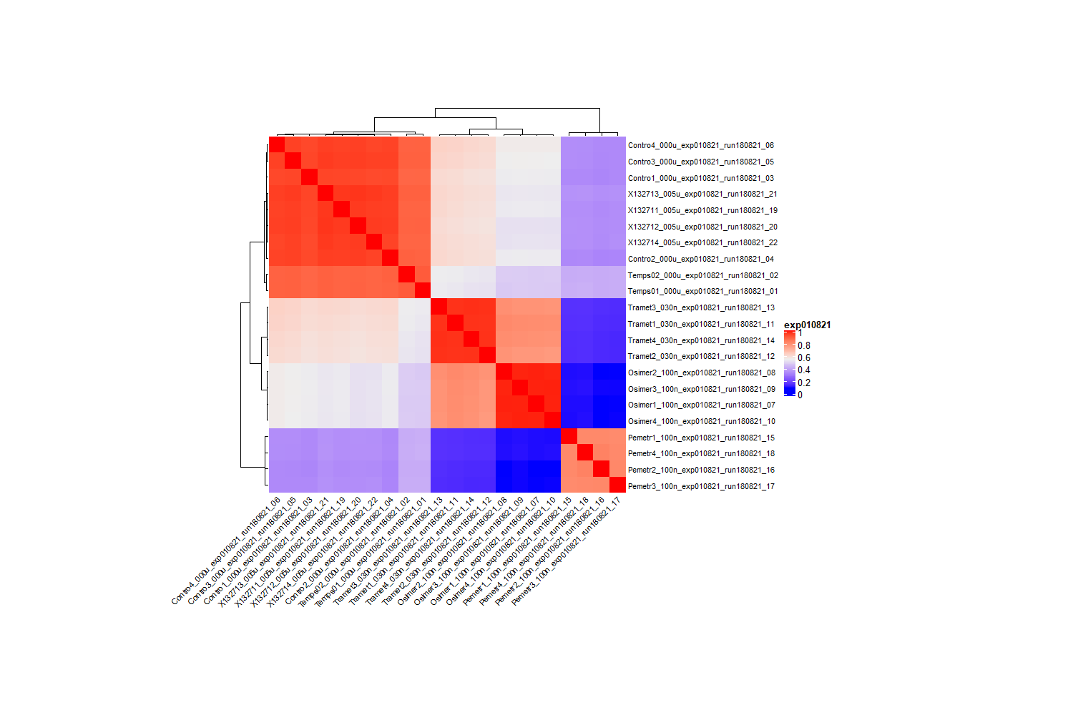

experiment B
The data is contained in the file Run210818_raw data.csv
This file contains initially 869’713 barcodes.
Controls are named :
Contro1_000u_exp040821_run180821_25
Contro2_000u_exp040821_run180821_26
Contro3_000u_exp040821_run180821_27
Contro4_000u_exp040821_run180821_28
We make a new column summing the 4 controls and use it to filter in order to drop every barcode that has 0 reads among the summed_controls.
The remaining data frame contains 120’268 barcodes that will be used to do the clustering.
The filtering reduced the number of barcodes by approximately 86%.
I’ll save the dataframe as a new csv file for further processing and analysis : Run210818_filtered_exp040821.csv
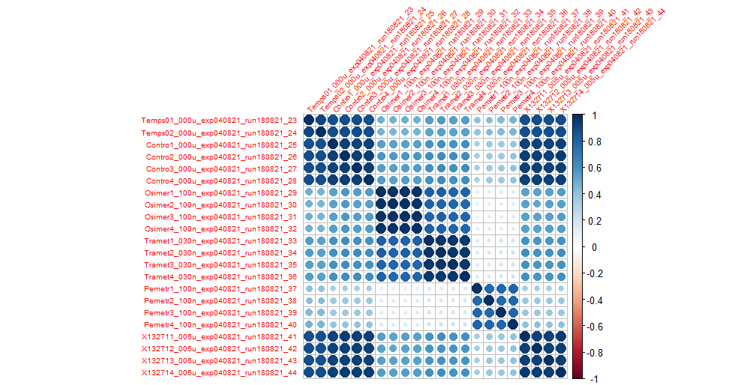
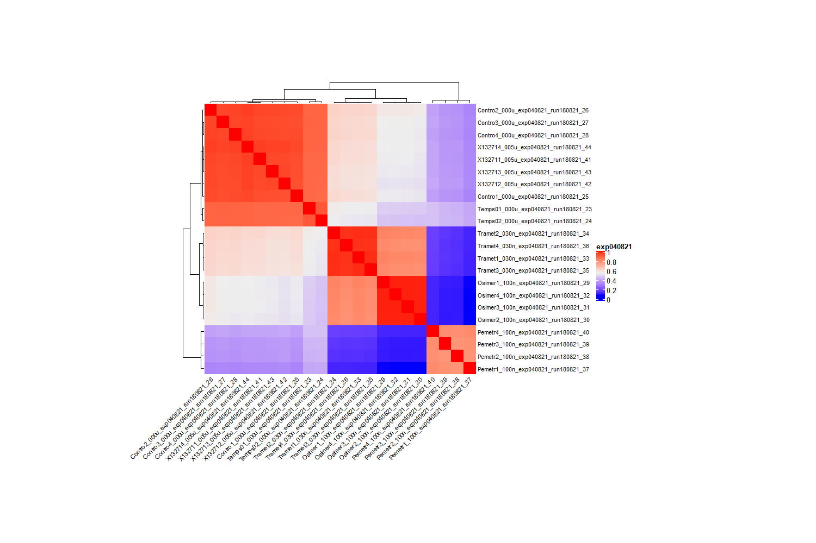

experiment C
The data is contained in the file Run210929_raw data.csv
This file contains initially 413’334 barcodes.
Controls are named :
Contro1_000u_exp300821_run290921_01
Contro2_000u_exp300821_run290921_02
Contro3_000u_exp300821_run290921_03
Contro4_000u_exp300821_run290921_04
We make a new column summing the 4 controls and use it to filter in order to drop every barcode that has 0 reads among the summed_controls.
The remaining data frame contains 56’640 barcodes that will be used to do the clustering.
The filtering reduced the number of barcodes by approximately 86%.
I’ll save the dataframe as a new csv file for further processing and analysis : Run210818_filtered_exp040821.csv
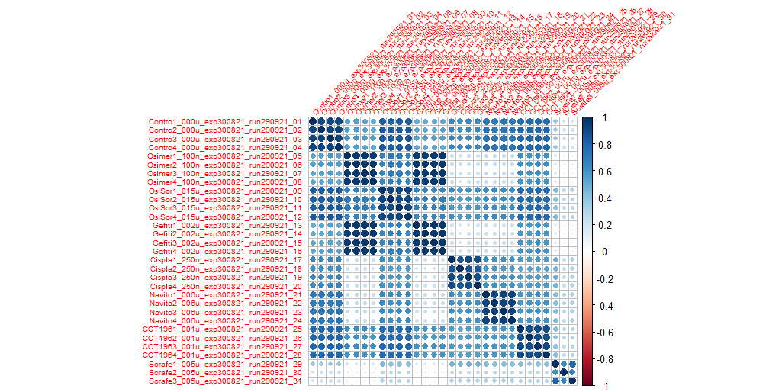

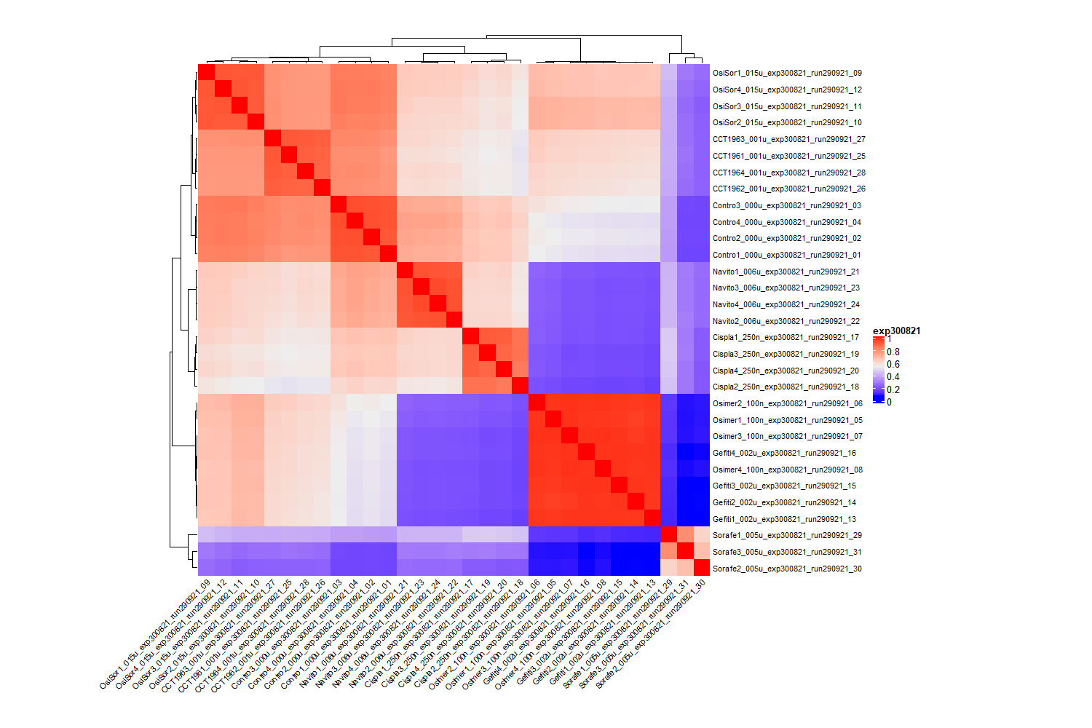

24/02/2022

Join the data from all runs
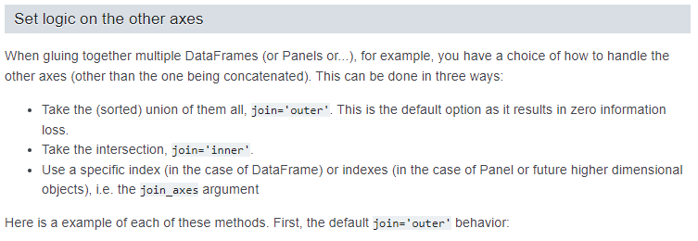
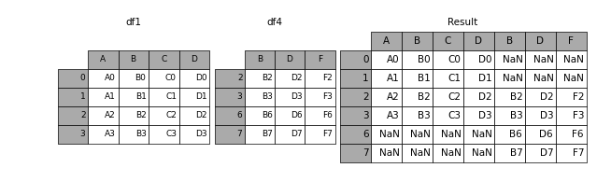

[2268353 rows x 380 columns]

Contro1_000u_exp010821_run180821_03
Contro2_000u_exp010821_run180821_04
Contro3_000u_exp010821_run180821_05
Contro4_000u_exp010821_run180821_06
Contro1_000u_exp040821_run180821_25
Contro2_000u_exp040821_run180821_26
Contro3_000u_exp040821_run180821_27
Contro4_000u_exp040821_run180821_28
Contro1_000u_exp300821_run290921_01
Contro2_000u_exp300821_run290921_02
Contro3_000u_exp300821_run290921_03
Contro4_000u_exp300821_run290921_04
Contro1_000u_exp130921_run290921_32
Contro2_000u_exp130921_run290921_33
Contro3_000u_exp130921_run290921_34
Contro4_000u_exp130921_run290921_35
Contro1_000u_exp200921_run111021_09
Contro2_000u_exp200921_run111021_10
Contro3_000u_exp200921_run111021_11
Contro4_000u_exp200921_run111021_12
Contro1_000u_exp130921_run101121_20
Contro2_000u_exp130921_run101121_21
Contro3_000u_exp130921_run101121_22
Contro4_000u_exp130921_run101121_23
Contro5_000u_exp130921_run101121_24
Contro6_000u_exp130921_run101121_25
Contro7_000u_exp130921_run101121_26
Contro8_000u_exp130921_run101121_27
Contro1_000u_exp181021_run101121_38
Contro2_000u_exp181021_run101121_39
Contro3_000u_exp181021_run101121_40
Contro4_000u_exp181021_run101121_41
Contro1_000u_exp151121_run071221_01
Contro2_000u_exp151121_run071221_02
Contro3_000u_exp151121_run071221_03
Contro4_000u_exp151121_run071221_04
Contro1_000u_exp271221_run180122_17
Contro2_000u_exp271221_run180122_18
Contro3_000u_exp271221_run180122_19
Contro4_000u_exp271221_run180122_20

→ 704’116’836 NaN values over 861’974’140 cells (2’268’353 rows x 380 columns)
→ ie 81.7% of the data is NaN
→ actual data represents 157’857’304 cells ( 861’974’140 - 704’116’836)
Check : Sum total cells of each run : 157’856’924…

→ We transform all the NaN values to 0 because it means that the barcode was not read from the samples (recently clarified with Luca on the call)
https://www.geeksforgeeks.org/replace-nan-values-with-zeros-in-pandas-dataframe/ ^^

- Absence of barcode in the rows of a given run means it has 0 reads in all samples from this run.

- Rename the 8 controls that were in “CtrlMsX_000u_exp130921_run101121_XX”, eg Contro1_000u_exp130921_run101121_20 → CtrlMs1_000u_exp130921_run101121_20

- How to get rid of the junk barcodes? There are 32 controls and 14 time_zeros columns.
- Barcodes have to be Present (at least 1 or 5 reads) in at least 5 controls (not the summed). Check how many sequences are left?
  - At least 1 read in at least 5 controls : 16’149 remaining barcodes (1)
  - At least 5 reads in at least 5 controls : 8’747 remaining barcodes (2)
- Barcodes have to be Present (at least 1) in all 32 controls (not the summed). Check how many sequences are left?
  - At least 1 read in all controls : 2’872 remaining barcodes (3)
- Barcodes have to be Present (at least 1 / 5 reads) in at least 5 controls + at least 5 of the timeZeros (not the summed). Check how many sequences are left?
  - At least 1 read in at least 5 controls and at least 5 time_zeros : 10’985 remaining barcodes (4)
  - At least 5 reads in at least 5 controls and at least 5 time_zeros : 7’922 remaining barcodes (5)
- Barcodes have to be Present (at least 1) in all controls and all the time_zeros(not the summed). Check how many sequences are left?
  - At least 1 read in all controls and all time_zeros : 2’330 remaining barcodes (6)

→ aim at between 10’000 and 25’000 different barcodes

- Then, normalization of the numbers of the reads.
For a given barcode B in the controls,
B = 200 in control 1,
B = 1000 in control 2,
B = 5000 in control 3,
…
→ divide by sum of reads. so that we compare proportions of reads instead of absolute reads

380 samples
[Aggregate the replicates (only if computing too slow)]

Correlation // try pearson and spearman
→ put 0 if pval non significant <0.05
→ weighted matrix and input in igraph (pay attention for it to be weighted for further filtering) to output a network

02/03/2022
- Normalize the counts within each sample to obtain relative counts, i.e. divide each count by the sum of total counts from the sample.

https://haroldpimentel.wordpress.com/2014/12/08/in-rna-seq-2-2-between-sample-normalization/

There have been several quite good papers published on between-sample normalization (BSN), some of which I’ve collected below. In almost all the methods, the techniques are simply different ways of finding a “control set” of expression features and using these to estimate your total depth, as opposed to using all of your data to estimate your total depth. While I offered a toy example on why it is important to have a control set of features, more complete examples can be found in Bullard et. al. and Robinson and Oshlack. The basic idea is that highly-variable expression features and differentially expressed features can eat a lot of your sequencing depth, thus throwing off the relative abundance of your expression features.

To be discussed…

03/03/2022
I generate a file with normalized read counts vertically, each cell being the percentage of the total counts within the same sample.

Test script :
$ python normalize_data_within_samples.py
df_test.csv
df
A B C
row1 10 2 10
row2 20 2 100
row3 30 10 0
percents_df
A B C
row1 16.666667 14.285714 9.090909
row2 33.333333 14.285714 90.909091
row3 50.000000 71.428571 0.000000

04/03/2022

Correlation matrix : 380 x 380
https://drive.google.com/drive/folders/1DqM2j65VVaIXswsdtfKIYMzUysKTsXCl
- filtered_reads_absolute.csv : they are the aggregated reads (380 samples in total) for 10'985 barcodes resulting from filtering out all the barcodes that were not found (at least 1 read) in at least 5 controls and at least 5 time_zeros samples.
- filtered_reads_percents.csv : this is the above dataframe, normalized by columns (samples) so that each reads number corresponds to the proportion of reads within that sample (ie total of reads = 100%)
- filtered_reads_millions.csv : same as above, but normalized to 1 million reads per sample.
- corr_mat.csv : the correlation matrix (pearson) 380 x 380
- corr_mat_pval.csv : same with *, **, *** following the correlation coefficient to inform about significance (respectively, pval 0.1, 0.05, 0.01)
- corr_plot.pdf : the correlation plot 380 x 380
- clustered_corr_plot.pdf : same as above but with samples clustered according to method='complete'

07/03/2022

Dendrogram
https://drive.google.com/drive/folders/1DqM2j65VVaIXswsdtfKIYMzUysKTsXCl

08/03/2022
Houssein deposited new data (Run010322) to the drive folder, I’ll add it to the already aggregated data frame and compute again the correlation matrix and associated analysis.
→ result7.csv

09/03/2022
result7.csv
→ replace_NaN.py
→ result7_fillna.csv

Discussion w/ Vera & Luca

Hi Nina,
In the analysis, you considered all the (real) barcodes. I think some populations behave in a certain way because they are intrinsically less sensitive to a given drug, while others behave more randomly. Could we find a way to get rid of the latter and only keep the barcodes for which the four replicates are consistent? They will not be the same for the different compounds, which may be a problem…

Also, we are looking at the global profile of all selected barcodes for each treatment. Could we consider each selected barcode as an individual cell subpopulation, and then focus on the populations that consistently respond in a similar way to different compounds?

*************************************************************************************************************
- What shall we do with the replicates? Average the counts?
- More barcode filtering → use the correlation found between replicates? But then, we might lose information from one sample to another. That leads again to the problem of clustering with missing data, right?
  - → evaluate how many barcodes are concerned for inconsistency among the 4 replicates, for all drugs.

- → evaluate variability among samples : (max - min) / average

- Try to display the counts as fold change compared to controls
- Another interesting question would be to evaluate the impact of a drug on variability, as compared to the control.

13/03/22
(Luca)
It could be difficult for further analysis not to consider barcodes that don’t show a consistent pattern within replicates. I thought that maybe we could use a more qualitative approach.
We could establish five (as an example) categories of barcodes/cells:

- barcodes/cells consistently enriched more than 5 (?) fold compared to the control (we should probably use the control from the same experiment to calculate the ratio)

- barcodes/cells consistently enriched between 2 and 5 fold over the control

- barcodes/cells with random/inconsistent behavior among replicates

- barcodes/cells consistently downregulated by at least 2 fold

- barcodes/cells consistently downregulated by more than 5 fold (or absent with the compound).

- barcodes/cells consistently between enriched 2 fold and downregulated 2 fold

For each compound, we will then have some kind of fingerprint that we can use to put together drugs with a similar mechanism of action. Also, for the comparison, each category/class should have a different weight: e.g. barcodes/cells enriched more than 5 fold should have a much stronger impact in the analysis as compared to barcodes/cells with inconsistent pattern.

Does it make sense? Do you think it’s doable?

→ Fold changes compared to controls averages within each experiment.
https://docs.google.com/spreadsheets/d/1r5hrUxgx6Mn5n4ge6Y34yMq9cRMZA93xcSXG78gusKQ/edit#gid=618126417

But barcodes are not always very ‘stable’ for all controls
→ https://docs.google.com/spreadsheets/d/1r5hrUxgx6Mn5n4ge6Y34yMq9cRMZA93xcSXG78gusKQ/edit#gid=546958792

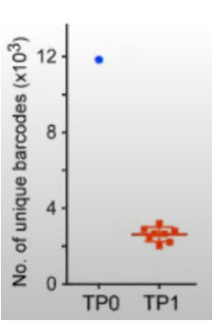

15/03/2022
Some ideas from Amy Brock’s talk
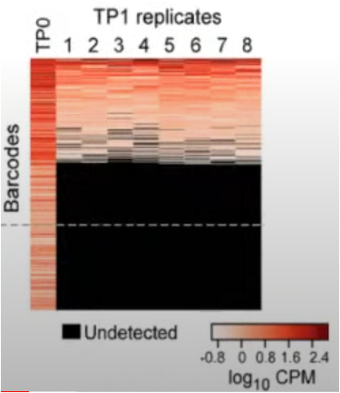
- Aggregating experiments, Plot the number of unique barcodes at Time Point 0 (controls/TimeZeros) and after treatments (compounds). E.g. :

- For each experiment, Plot Barcodes proportions (log10 Counts Per Million). E.g. :

- For each series of replicates, what percentage of clones is common throughout replicates? Then, what proportion of the total population (total reads) do these clones represent?

18/03/2022

- Controls averages and stdev
Test for the 1st barcode of the filtered data (6) : 2330 barcodes in total
print(experiment, controls[1:4], controls_avg, controls_stdev,avg_std, max_min)

exp_id | control1 | control2 | control3 | control4 | avg | stdev | avg/stdev | (max-min)/avg
exp181021 | 873.0 | 560.0 | 708.0 | 795.0 | 734.0 | 134.16 | 5.47 | 0.43
exp200921 | 359.0 | 511.0 | 510.0 | 493.0 | 468.25 | 73.3 | 6.39 | 0.32
exp010821 | 290.0 | 371.0 | 543.0 | 631.0 | 458.75 | 155.93 | 2.94 | 0.74
exp151121 | 449.0 | 306.0 | 336.0 | 438.0 | 382.25 | 71.92 | 5.31 | 0.37
exp040821 | 536.0 | 509.0 | 452.0 | 417.0 | 478.5 | 53.92 | 8.87 | 0.25
exp130921 | 572.0 | 263.0 | 195.0 | 173.0 | 300.75 | 184.85 | 1.63 | 1.33
exp271221 | 117.0 | 115.0 | 168.0 | 111.0 | 127.75 | 26.95 | 4.74 | 0.45
exp300821 | 603.0 | 478.0 | 518.0 | 672.0 | 567.75 | 86.87 | 6.54 | 0.34

- Heatmap displaying the (max-min)/avg value for each barcode in each experiment within the 4 control replicates. 2330 barcodes in total
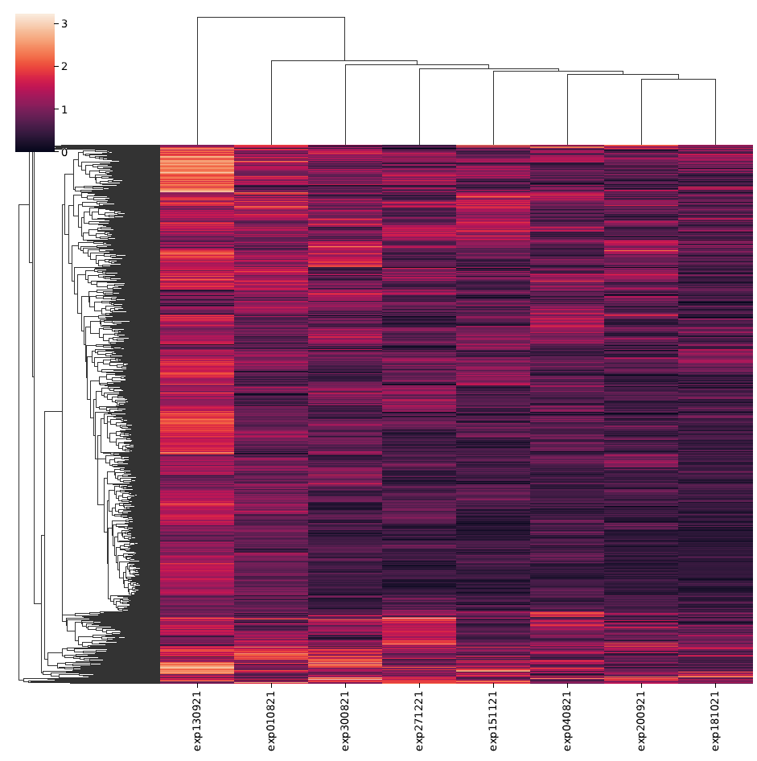
If we drop all barcodes that have a (max-min)/avg > 1, we reduce the barcodes number from 2330 to 82 barcodes… This is too drastic.
On filtered data (4) : 10985 barcodes in total
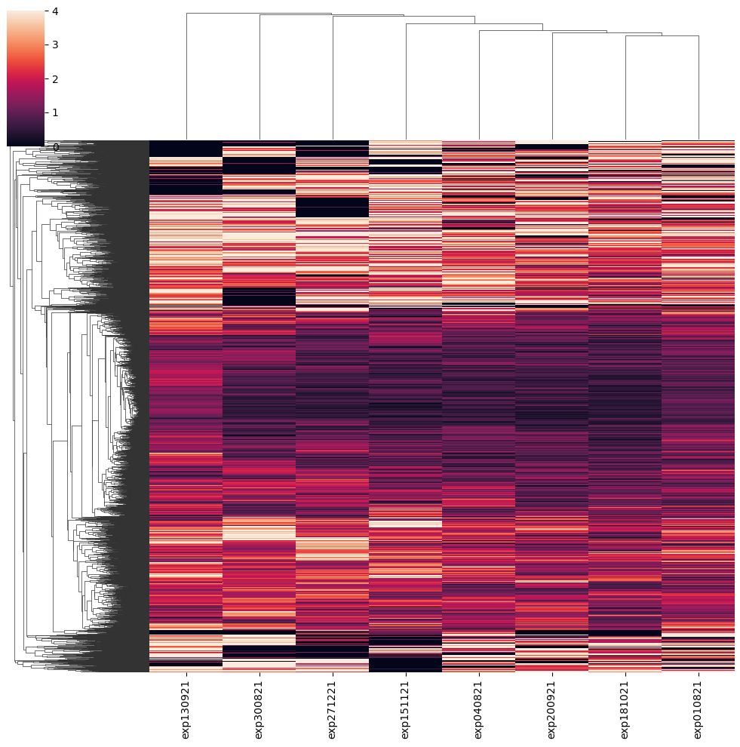

If we drop all (max-min)/avg > 1 :
10985 barcodes > 83 barcodes

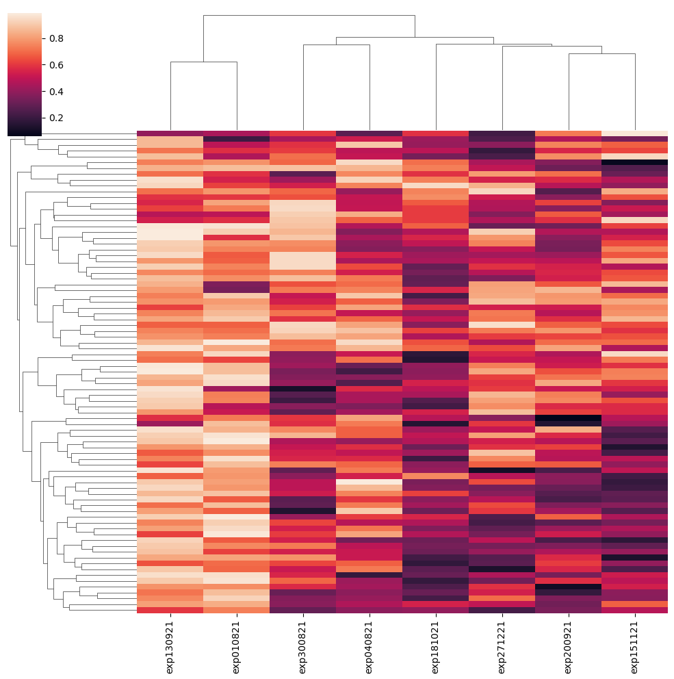

Fold Change

Heatmap of (max-min)/avg from fold changes values:
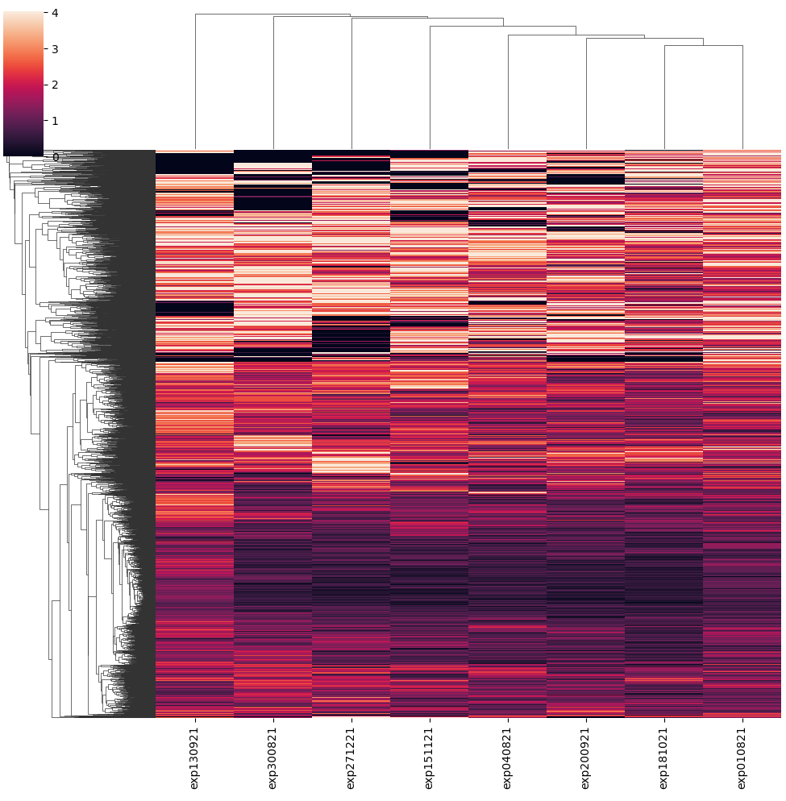

Filter threshold (max-min)/avg < 2
(from 10985 barcodes to 2504 barcodes)
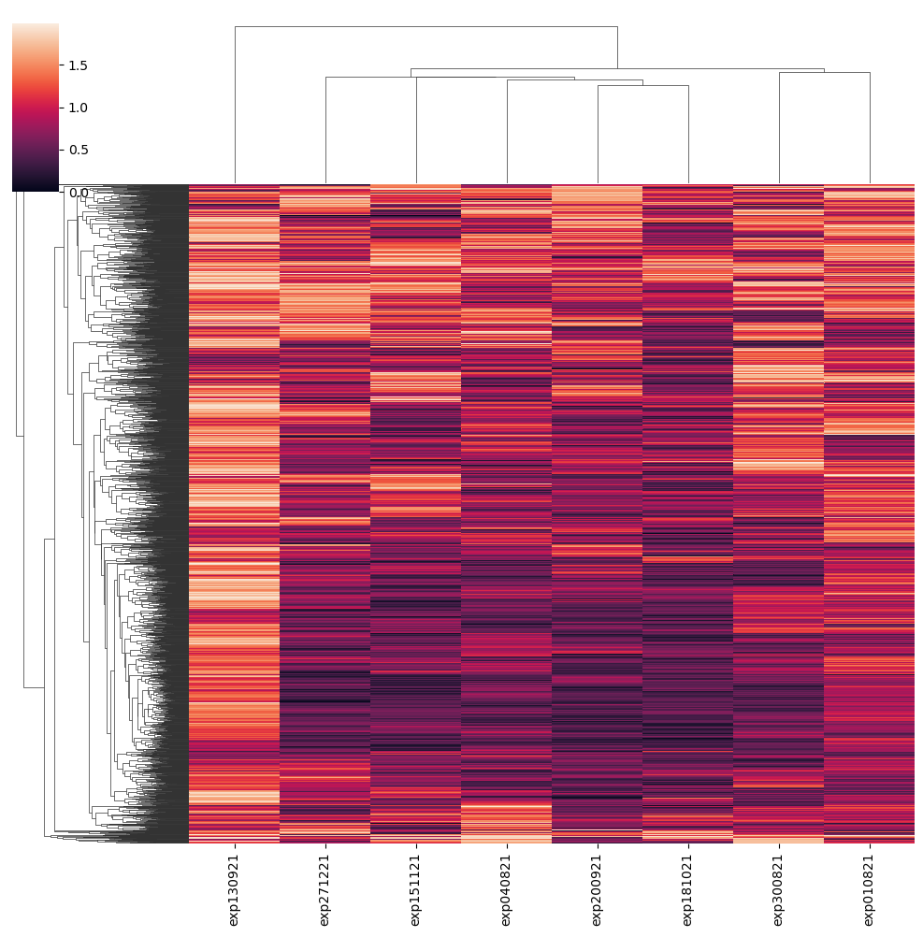

29/03/2022
https://drive.google.com/drive/u/0/folders/12g105Qq2fbEtBdz9DzXYj_EDl2MycUua

Log fold change shrinkage for visualization and ranking
Shrinkage of effect size (LFC estimates) is useful for visualization and ranking of genes. To shrink the LFC, we pass the dds object to the function lfcShrink
The options for type are:
- apeglm is the adaptive t prior shrinkage estimator from the apeglm package (Zhu, Ibrahim, and Love 2018). As of version 1.28.0, it is the default estimator.
- ashr is the adaptive shrinkage estimator from the ashr package (Stephens 2016). Here DESeq2 uses the ashr option to fit a mixture of Normal distributions to form the prior, with method="shrinkage".
- normal is the the original DESeq2 shrinkage estimator, an adaptive Normal distribution as prior.
apeglm: Heavy-tailed prior distributions for sequence count data: removing the noise and preserving large differences. Bioinformatics. 10.1093/bioinformatics/bty895
ashr: False discovery rates: a new deal. Biostatistics, 18:2. 10.1093/biostatistics/kxw041

NB: we are working on the Barcodes present with at least 1 read in at least 5 controls and at least 5 time_zeros resulting in a filtering from a total of 2’268’353 barcodes to 10’985 remaining barcodes (4).
The filtered file is called “result6_fillna_control_renamed_filtered4.csv” (18.4Mb)
Unfiltered file is called “result6_fillna_control_renamed.csv” (3.46Gb)

Barcode number of reads variability within controls.

Frequency plots
  - All experiments
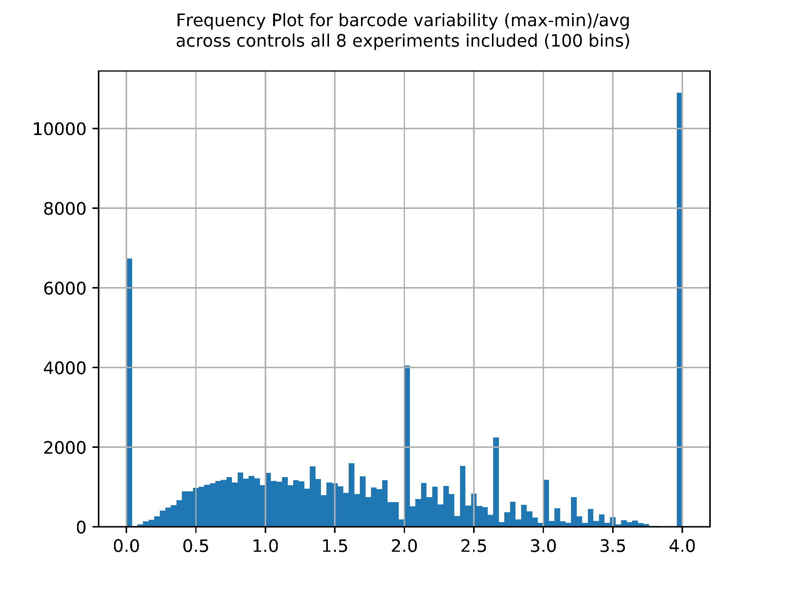

  - Groupby experiment
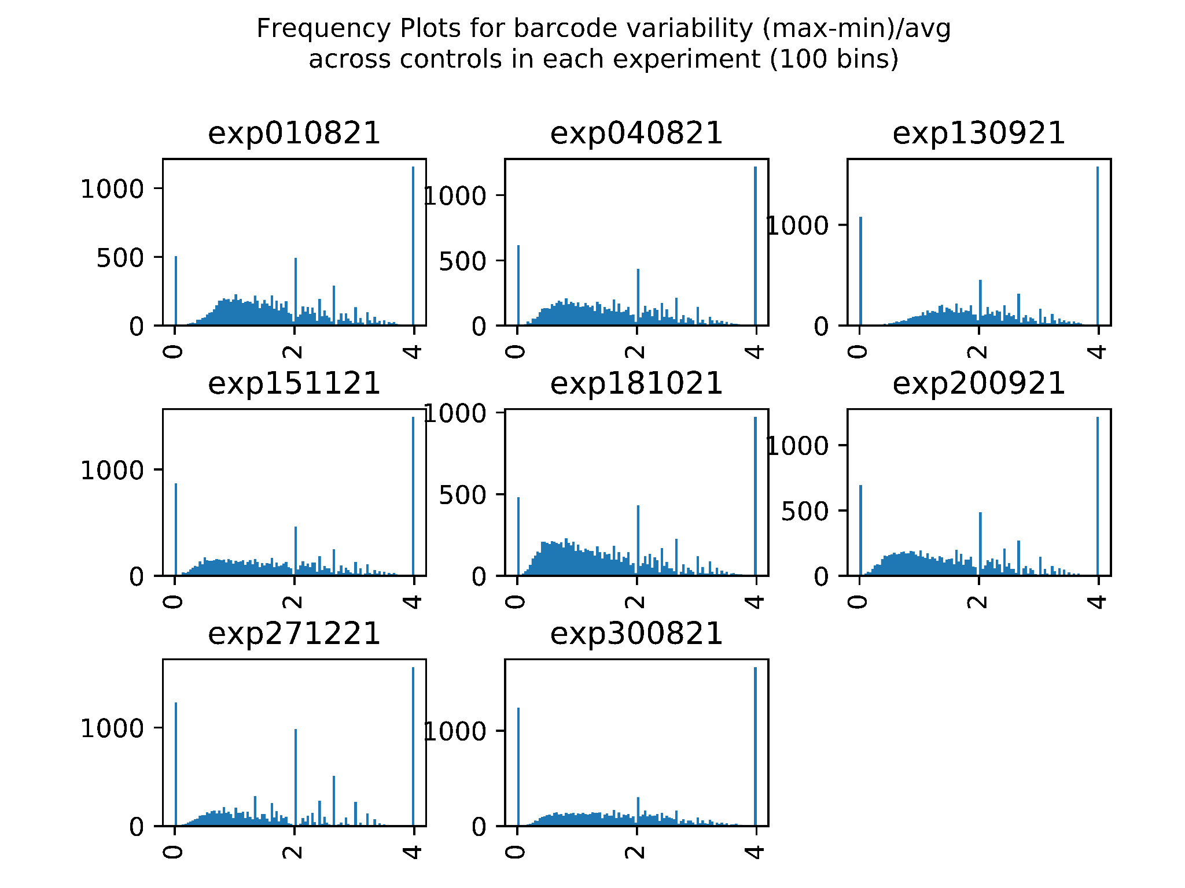

Density plots.

Groupby experiment

See https://pandas.pydata.org/docs/reference/api/pandas.DataFrame.plot.density.html
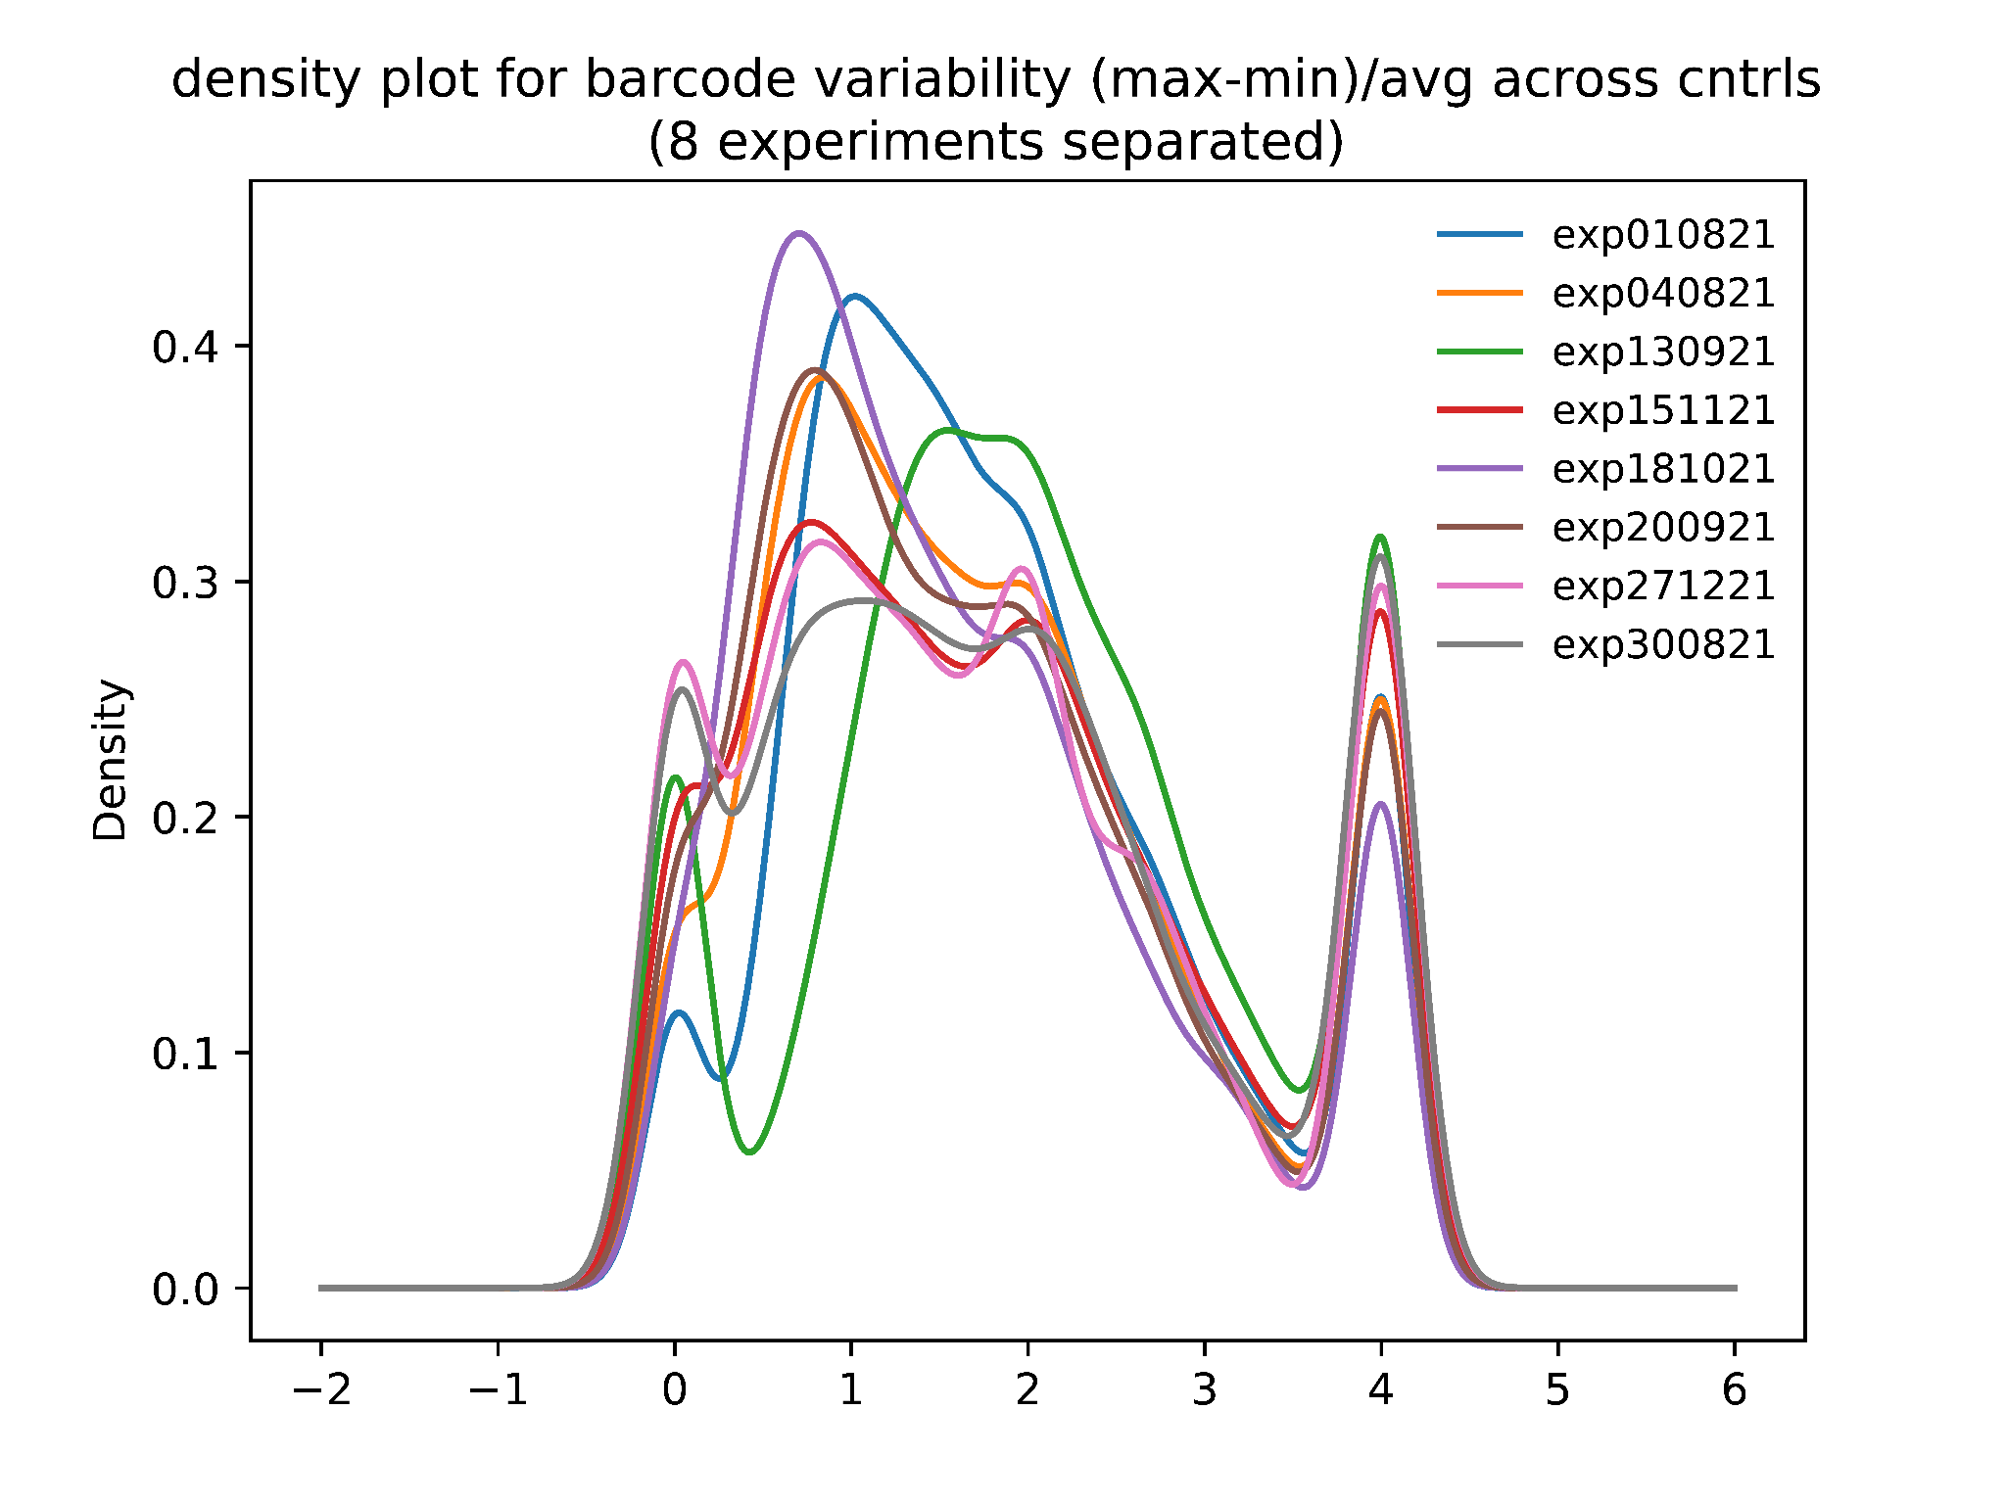

See https://seaborn.pydata.org/generated/seaborn.violinplot.html

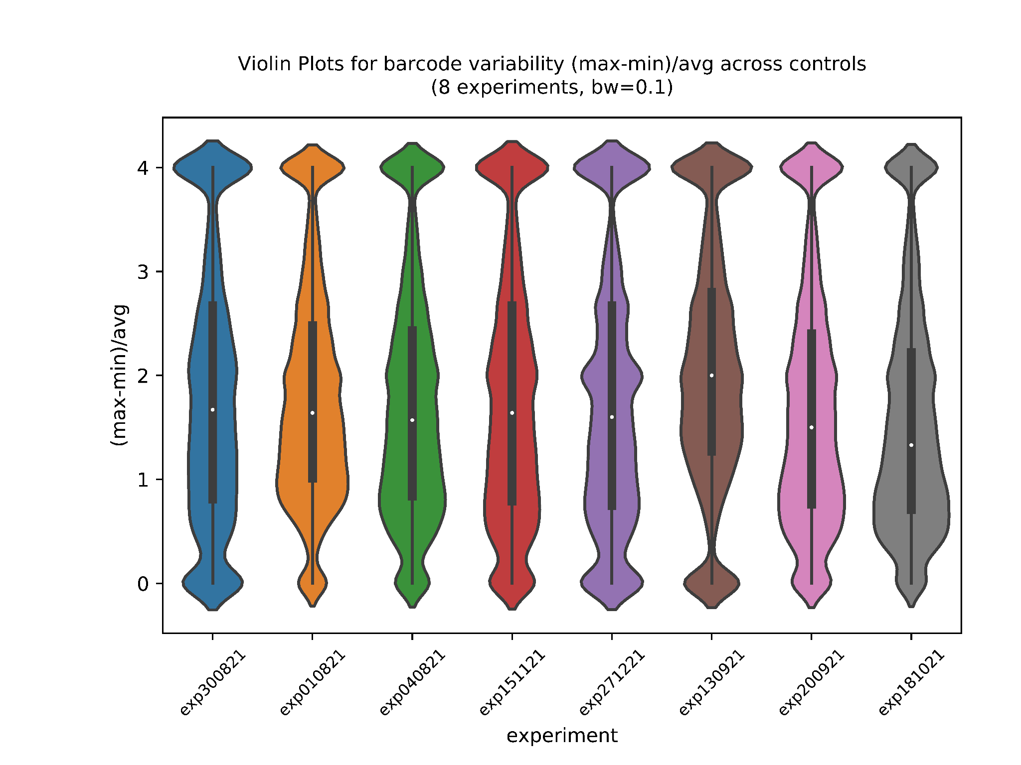

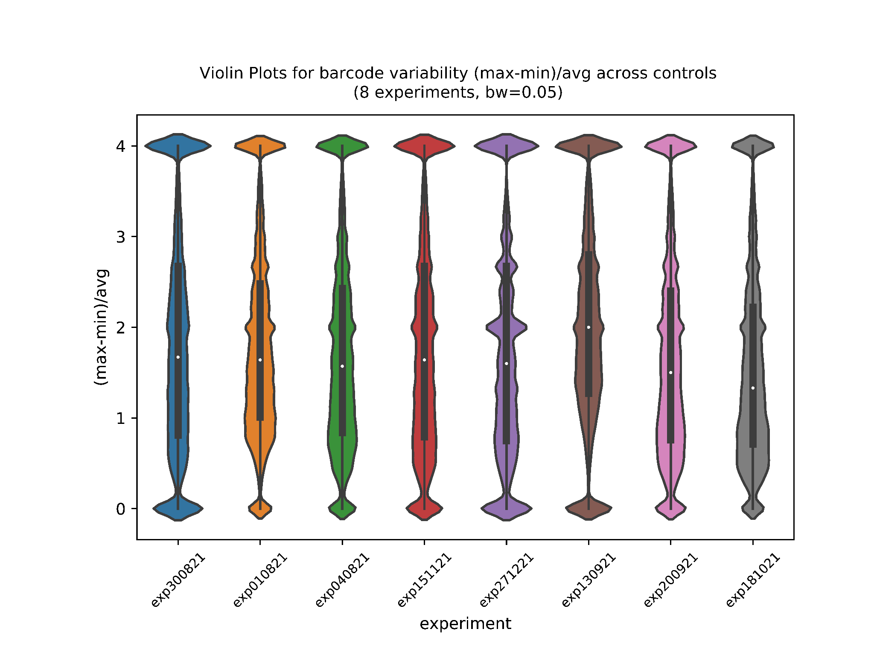

Including all experiments
See https://pandas.pydata.org/docs/reference/api/pandas.DataFrame.plot.kde.html
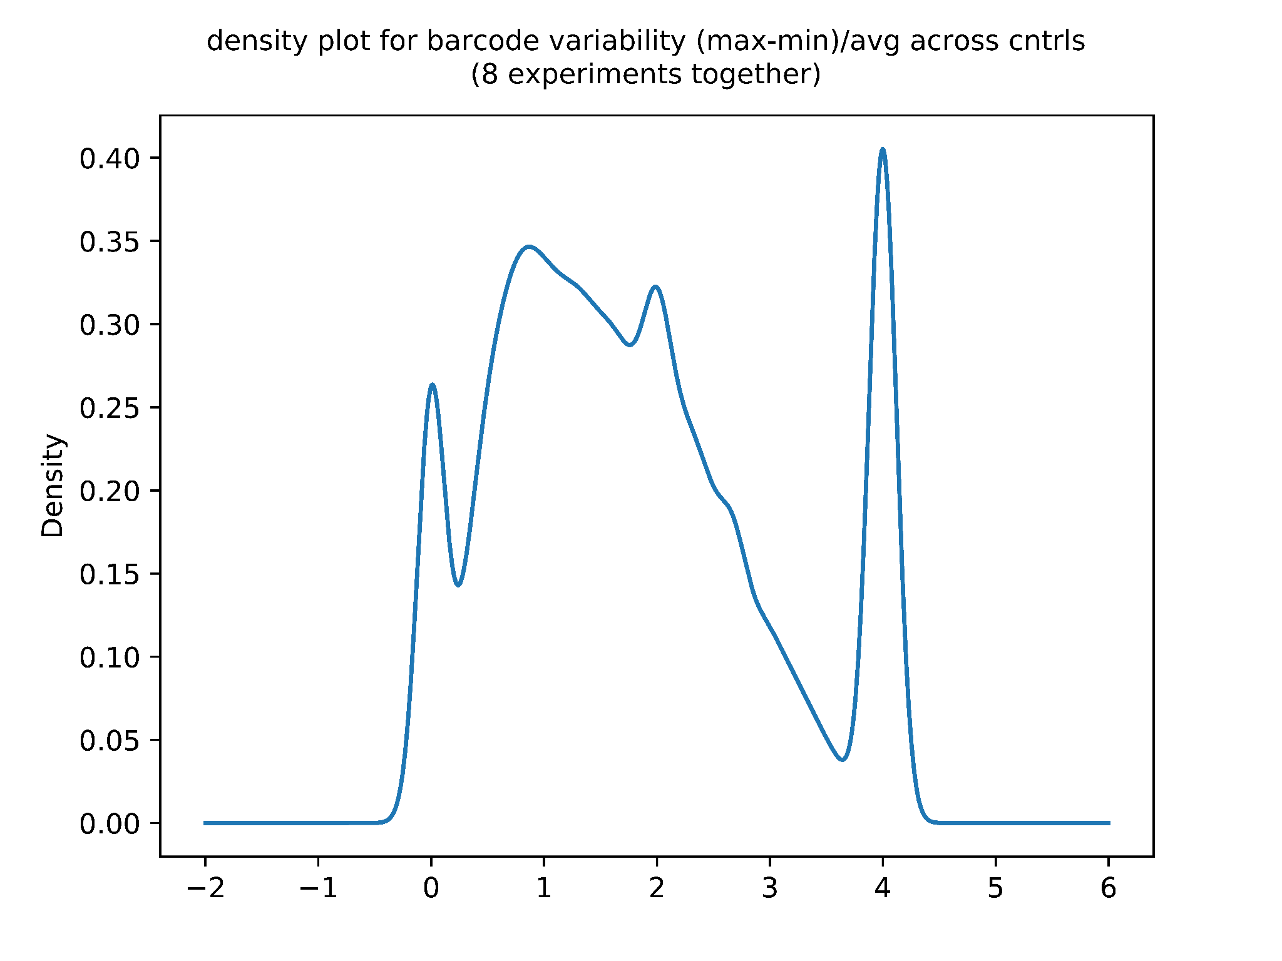

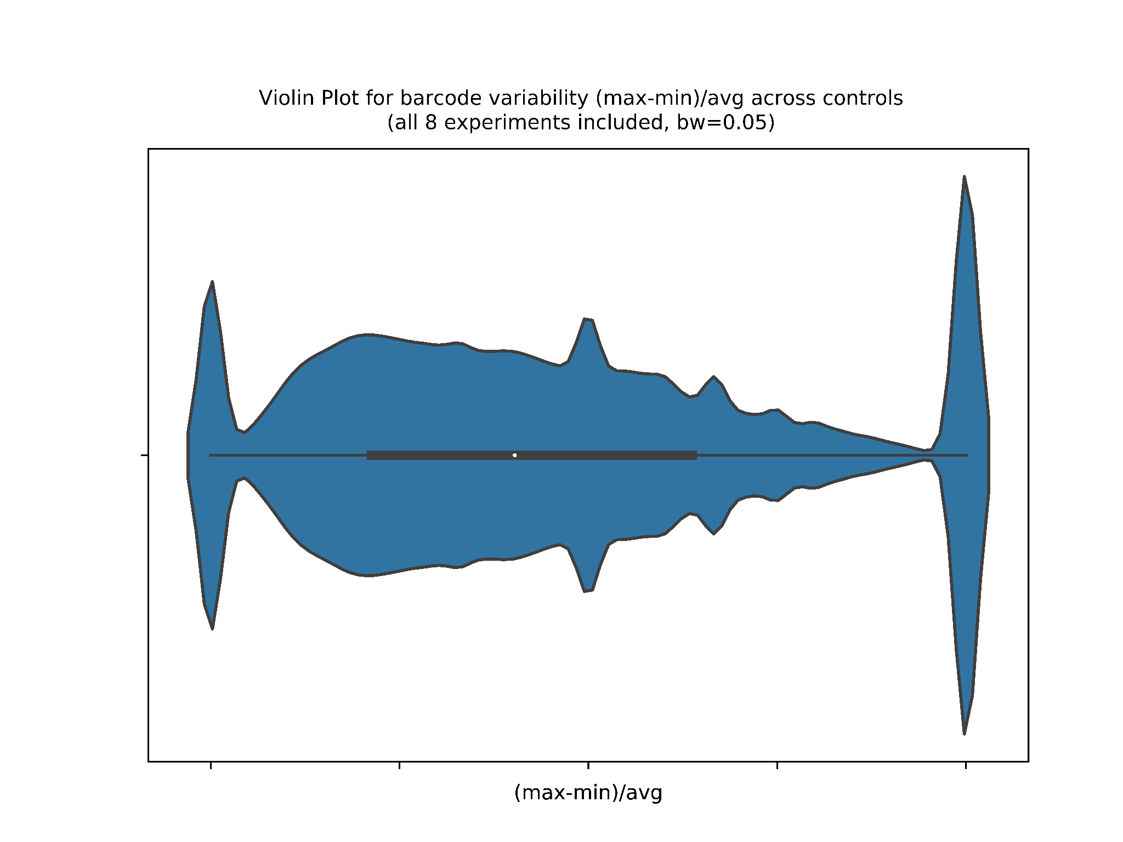

Averaging variability over the 8 experiments
https://docs.google.com/spreadsheets/d/1r5hrUxgx6Mn5n4ge6Y34yMq9cRMZA93xcSXG78gusKQ/edit#gid=355011523

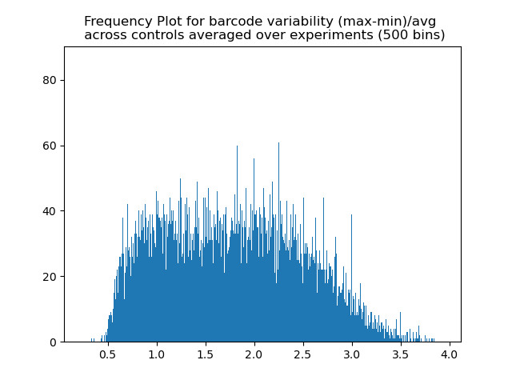
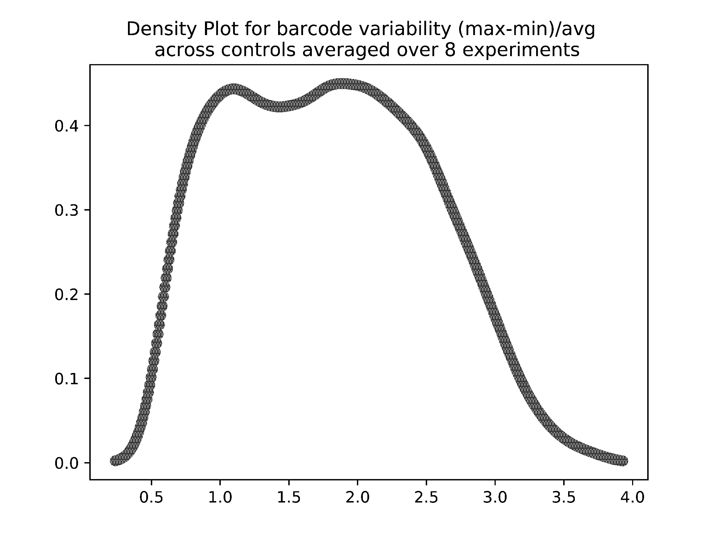

Fold changes
Barcodes’ number of reads expressed as fold changes compared to avg number of reads in controls
https://docs.google.com/spreadsheets/d/1r5hrUxgx6Mn5n4ge6Y34yMq9cRMZA93xcSXG78gusKQ/edit#gid=618126417

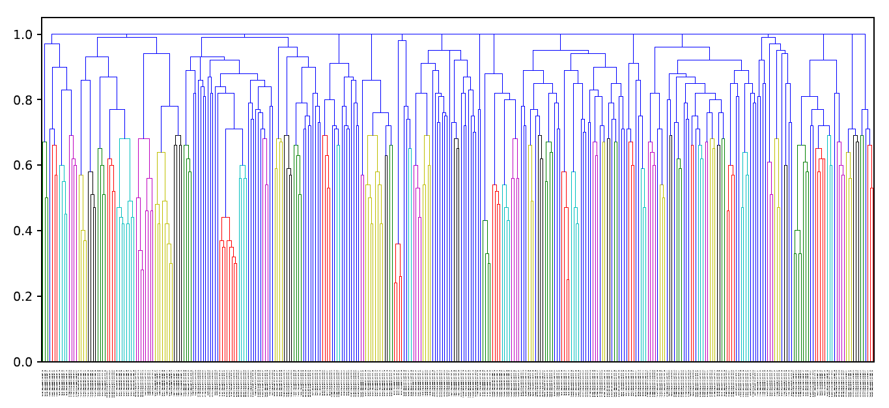

PCA analysis on Controls

Question :
Can the different experiments be compared with each other? I.e. Are the reads counts in the controls comparable?
→ PCA analysis with prcromp function from the stats package in R
https://cran.r-project.org/web/packages/ggfortify/vignettes/plot_pca.html

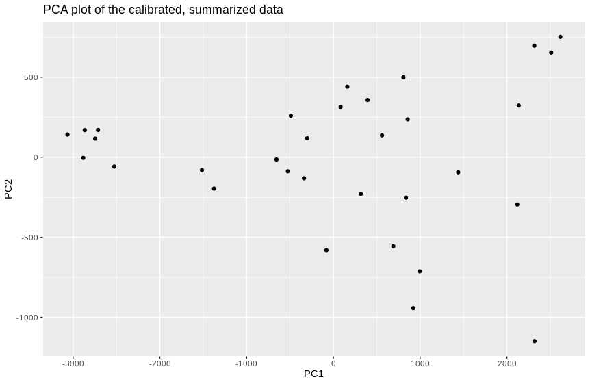
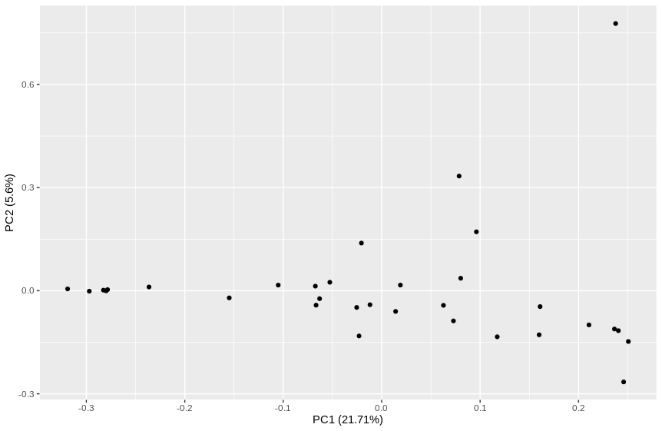

Unique Barcodes
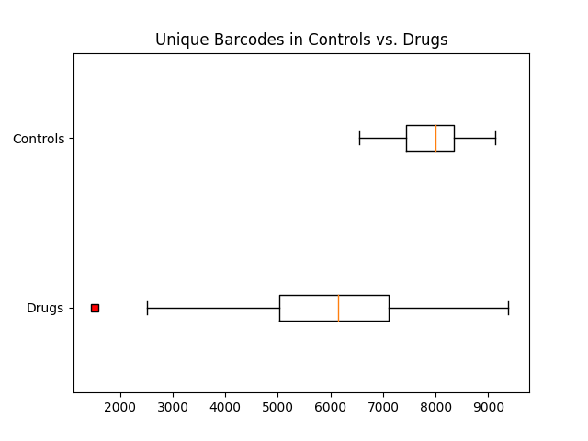

Barcodes counts
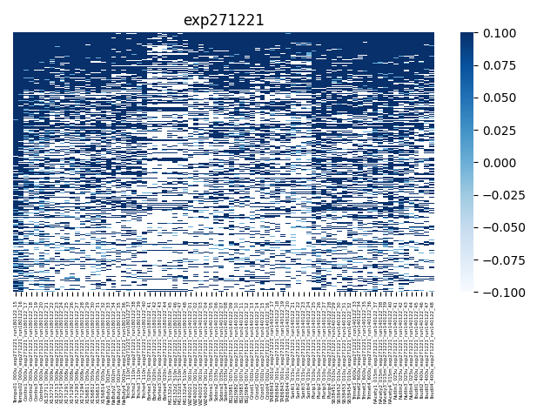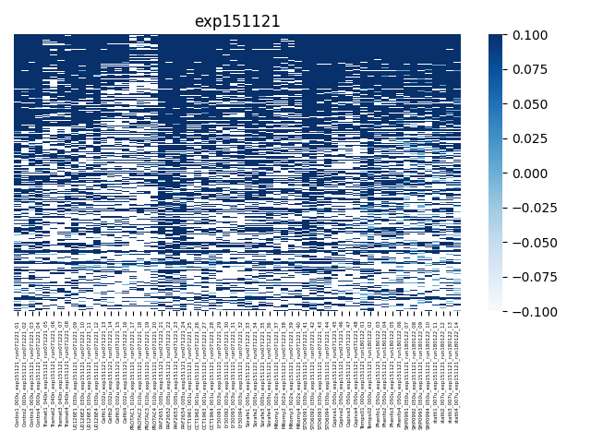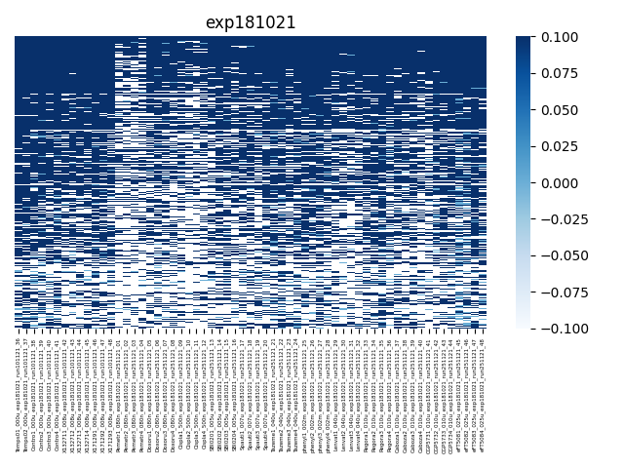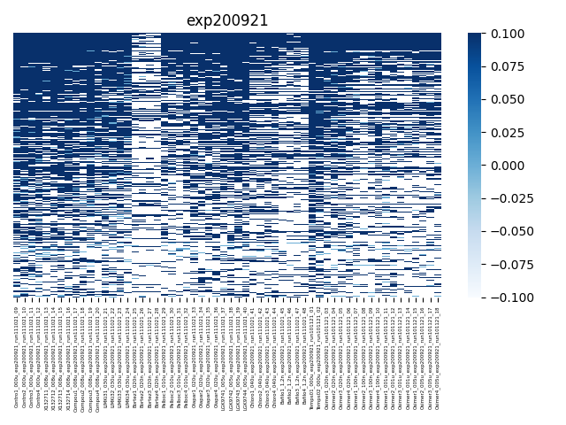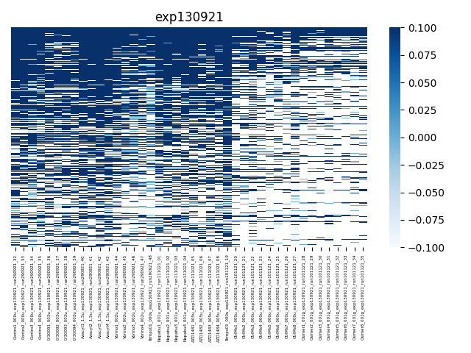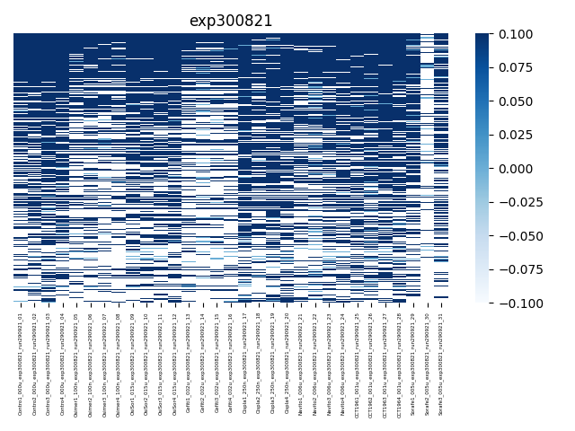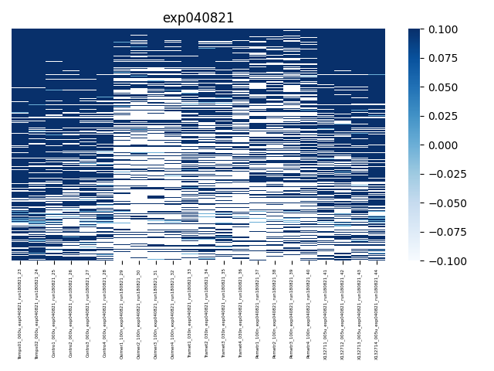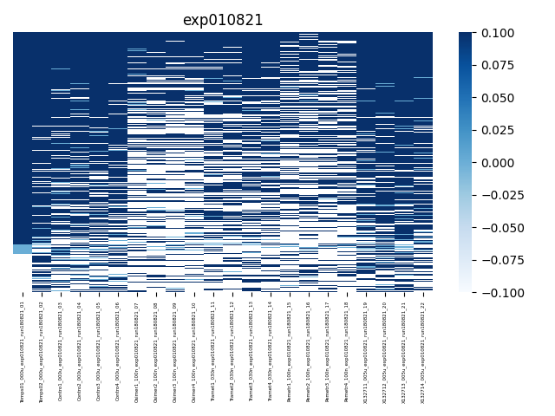

Differential barcode counts
- Averaging the controls and calculating the ratio for each count
→ See the averaged counts, fold changes and correlations in folder averaged_replicates

- Use DESeq2
http://bioconductor.org/packages/devel/bioc/vignettes/DESeq2/inst/doc/DESeq2.html
[...] An important analysis question is the quantification and statistical inference of systematic changes between conditions, as compared to within-condition variability. The package DESeq2 provides methods to test for differential expression by use of negative binomial generalized linear models; the estimates of dispersion and logarithmic fold changes incorporate data-driven prior distributions.

→ input data should be un-normalized counts
http://bioconductor.org/packages/devel/bioc/vignettes/DESeq2/inst/doc/DESeq2.html#why-un-normalized-counts
The DESeq2 model internally corrects for library size, so transformed or normalized values such as counts scaled by library size should not be used as input.

https://www.youtube.com/watch?v=0b24mpzM_5M

- check if the assumptions () made on genes for DESeq2 still hold for barcodes data

- Plot total number of barcodes in each condition… Do we have much less barcodes in treated vs untreated?

→ check total numbers of barcodes per condition here : https://drive.google.com/drive/folders/1Ul5iy4SwtuHgaGpLadt2zkXoHRGITHo3?usp=sharing

Comment sont considérés les 0 et NaN dans la corrélation? → ils sont ignorés
https://pandas.pydata.org/docs/reference/api/pandas.DataFrame.corr.html

→ Drug_signature : pour chaque condition, results deseq2, sélectionner les barcodes qui ont une pval < 0.005 et qui ont Log2FC grand ou petit, de sorte à générer des signatures pour chaque drogues. GSEA avec nos propres sets/ signatures

→ relancer le clustering sur les barcodes filtrés par pval

Luca’s comments, 02/05/22
Hi Nina,
Sorry for the late reply, but I wanted to play around with the numbers and, for some reasons, I struggled a lot with excel (finally I had to replace dots with commas to use the if function). I'm still thinking of a way to take into account the replicates (and focus on barcodes behaving similarly) and I wanted to combine the "fold changes" and "filtered reads" files. I noticed that reads in "filtered reads" are not normalized, do you remember whether you used normalized reads to generate the "fold changes" file? I selected a few conditions (from one experiment) for a test (osimertinib, trametinib, pemetrexed, vorinostat and sodium phenylbutyrate). I tried to sort reads that were >2 fold enriched in all four replicates and, out of the 10481 barcodes, I found 669 for osimertinib, 798 for trametinib, 1046 for pemetrexed, but only 38 for vorinostat and 81 for sodium phenylbutyrate (these last two compounds are supposed to function through a similar mechanism). However, when I calculated the correlations, I found that the four vorinostat replicates were as close (between 0.799 and 0.765) as the four pemetrexed replicates (between 0.8006 and 0.7767), which doesn't look very consistent (only 0.36% of the barcodes were enriched at least 2 fold in the four vorinostat replicates, yet the correlation is almost 0.8). When you have some time, maybe we can discuss.
Thanks,
Luca
PS The correlations between vorinostat and sodium phenylbutyrate were not too bad (between 0.6546 and 0.5777), higher compared to those with the other samples.
PPS I had to replace nan with 0

Luca’s comments 09/05/22

Hi Nina,
I looked at the data, some seem consistent with the mechanisms, but others not really. I don't think that combining the different replicates for each drug is the way to go, we need to find a way to focus on the populations that show a predefined response and get rid of those that behave randomly. I was thinking that maybe we could select for each drug a limited number of barcodes (either a predefined number, like 10 or 5 % of the 10K, or a calculated number) to have at the same time the highest correlation among drug replicates and the lowest correlation between drug and control replicates. Then we could use the selected barcodes to compare, one to one, both ways, the different treatments (drug 1 vs drug 2 based on the barcodes selected for drug 1; drug 2 vs drug 1 based on the barcodes selected for drug 2). Does it make sense? Do you think it would be possible? Happy to discuss whenever you are available.

GSEA
https://www.gsea-msigdb.org/gsea/doc/GSEAUserGuideFrame.html?Preparing_Data_Files

https://software.broadinstitute.org/cancer/software/gsea/wiki/index.php/Data_formats#TXT:_Text_file_format_for_expression_dataset_.28.2A.txt.29

Prepare your own Gene sets file :
https://software.broadinstitute.org/cancer/software/gsea/wiki/index.php/Data_formats#GMT:_Gene_Matrix_Transposed_file_format_.28.2A.gmt.29

Permutation type. Select the type of permutation to perform in assessing the statistical significance of the enrichment score:
▪ Phenotype. Random phenotypes are created by shuffling the phenotype labels on the samples. For each random phenotype, GSEA ranks the genes and calculates the enrichment score for all gene sets. These enrichment scores are used to create a null distribution from which the significance of the actual enrichment score (for the actual expression data and gene set) is calculated. This is the recommended method when there are at least seven (7) samples in each phenotype.
▪ Gene_set. Random gene sets, size matched to the actual gene set, are created and their enrichment scores calculated. These enrichment scores are used to create a null distribution from which the significance of the actual enrichment score (for the actual gene set) is calculated. This method is useful when you have too few samples to do phenotype permutations (that is, when you have fewer than seven (7) samples in any phenotype).
The GSEA team recommends using phenotype permutation whenever possible. The phenotype permutation shuffles the phenotype labels on the samples in the dataset; it does not modify gene sets. Therefore, the correlations between the genes in the dataset and the genes in a gene set are preserved across phenotype permutations. The gene_set permutation creates random gene sets; therefore, the correlations between the genes in the dataset and the genes in the gene set are not preserved across gene_set permutations. Preserving the gene-to-gene correlation across permutations provides a more biologically reasonable (more stringent) assessment of significance.
Note: In previous versions of GSEA, gene_set permutation was referred to as tag permutation.

gsea-cli.sh GSEA -res /home/nina/Projects/2022_Barcodes/scripts_bckp_20220331/result6_fillna_control_renamed_filtered4_millions_GSEA_formatted.txt -cls /home/nina/Projects/2022_Barcodes/my_pheno.cls#AZD148_005u_versus_control -gmx /home/nina/Projects/2022_Barcodes/DeSeq2/signatures_matrix.gmt -collapse No_Collapse -mode Max_probe -norm meandiv -nperm 1000 -permute phenotype -rnd_seed timestamp -rnd_type no_balance -scoring_scheme weighted -rpt_label my_analysis -metric Signal2Noise -sort real -order descending -create_gcts false -create_svgs false -include_only_symbols true -make_sets true -median false -num 100 -plot_top_x 20 -save_rnd_lists false -set_max 500 -set_min 15 -zip_report false -out /home/nina/gsea_home/output/jun01

31/05/2022
Houssein wrote to me to say 2 additional runs are available in the drive.
I’ll reprocess all the data together including Run010322, Run060522, Run200522 to the other 8 runs (210818, 210929, 211011, 211110, 211125, 211207, 220112-220118, 220114)

Volcano plots
Is logFC related to pval?
Cutoff only on pval → how many barcodes remain in each drug?
Run the clustering on these

Try alternative annotations of the drugs to evaluate the clustering
https://lincsproject.org/LINCS/data/overview

10/06/2022
Q. Cutoff only on pval → how many barcodes remain in each drug?
Raw ie Before cutoff on pval : between 10’871 and 10’980 barcodes
After cutoff on pval (< 0.05) : between 129 and 4’589 barcodes
After pval < 0.05 and log2fc > 1 : between 32 and 2’352 barcodes

https://docs.google.com/spreadsheets/d/1r5hrUxgx6Mn5n4ge6Y34yMq9cRMZA93xcSXG78gusKQ/edit#gid=1915968529

On raw results,
Union = 10’985 barcodes
Intersection = 10’813 barcodes

On filtered results for pval < 0.5,
Union = 9605 barcodes, but the clustering doesnt work as there are too many NAs
Intersection = 0 barcodes …
But with removing barcodes for which there more than 10 NAs,
merged_df = merged_df.dropna(axis=0, thresh=10)
Intersection = 6341 barcodes.
Thresh = 5 → 7930
Thresh = 20 → 3483
30 → 1589
40 → 447

exp010821
[3, 4, 5, 6]
[1, 2, 7, 8, 9, 10, 11, 12, 13, 14, 15, 16, 17, 18, 19, 20, 21, 22] 18
exp040821
[25, 26, 27, 28]
[23, 24, 29, 30, 31, 32, 33, 34, 35, 36, 37, 38, 39, 40, 41, 42, 43, 44] 18
exp300821
[45, 46, 47, 48]
[49, 50, 51, 52, 53, 54, 55, 56, 57, 58, 59, 60, 61, 62, 63, 64, 65, 66, 67, 68, 69, 70, 71, 72, 73, 74, 75] 27
exp130921
[76, 77, 78, 79]
[80, 81, 82, 83, 84, 85, 86, 87, 88, 89, 90, 91, 92, 93, 94, 95, 96, 97, 98, 99, 100, 159, 160, 161, 162, 163, 164, 165, 166, 167, 168, 169, 170, 171, 172, 173, 174, 175] 38
exp200921
[101, 102, 103, 104]
[105, 106, 107, 108, 109, 110, 111, 112, 113, 114, 115, 116, 117, 118, 119, 120, 121, 122, 123, 124, 125, 126, 127, 128, 129, 130, 131, 132, 133, 134, 135, 136, 137, 138, 139, 140, 141, 142, 143, 144, 145, 146, 147, 148, 149, 150, 151, 152, 153, 154, 155, 156, 157, 158] 54
exp181021
[178, 179, 180, 181]
[176, 177, 182, 183, 184, 185, 186, 187, 188, 189, 190, 191, 192, 193, 194, 195, 196, 197, 198, 199, 200, 201, 202, 203, 204, 205, 206, 207, 208, 209, 210, 211, 212, 213, 214, 215, 216, 217, 218, 219, 220, 221, 222, 223, 224, 225, 226, 227, 228, 229, 230, 231, 232, 233, 234, 235, 236] 57
exp151121
[237, 238, 239, 240]
[241, 242, 243, 244, 245, 246, 247, 248, 249, 250, 251, 252, 253, 254, 255, 256, 257, 258, 259, 260, 261, 262, 263, 264, 265, 266, 267, 268, 269, 270, 271, 272, 273, 274, 275, 276, 277, 278, 279, 280, 281, 282, 283, 284, 285, 286, 287, 288, 289, 290, 291, 292, 293, 294, 295, 296, 297, 298] 58
exp271221
[301, 302, 303, 304]
[299, 300, 305, 306, 307, 308, 309, 310, 311, 312, 313, 314, 315, 316, 317, 318, 319, 320, 321, 322, 323, 324, 325, 326, 327, 328, 329, 330, 331, 332, 333, 334, 335, 336, 337, 338, 339, 340, 341, 342, 343, 344, 345, 346, 347, 348, 349, 350, 351, 352, 353, 354, 355, 356, 357, 358, 359, 360, 361, 362, 363, 364, 365, 366, 367, 368, 369, 370, 371, 372, 373, 374, 375, 376, 377, 378, 379, 380] 78

